EXPERIMENT:240701313 NAME: MITHULES

USER INTERFACE AND DESIGN

Mind Vault: A Game-Based Learning System for Chunking, Recall, and Recognition

Mind Valut: Access Granted
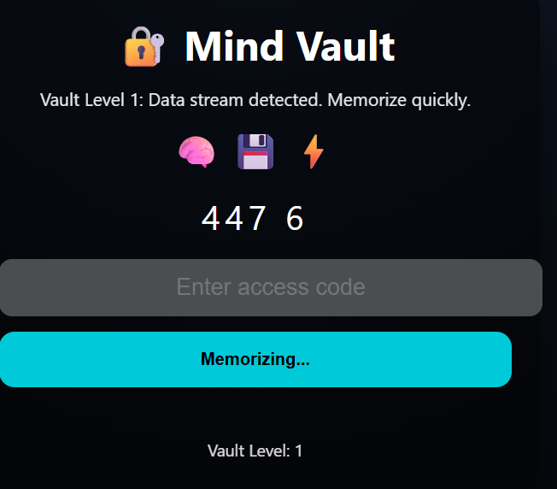

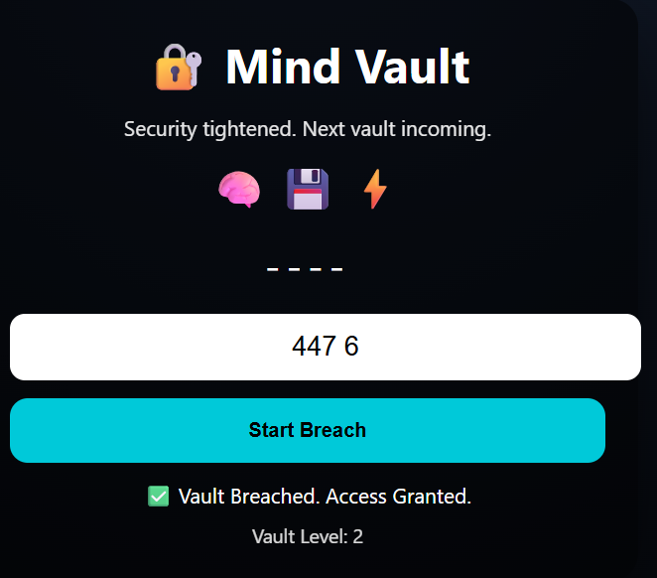
Mind Valut: Access Denied
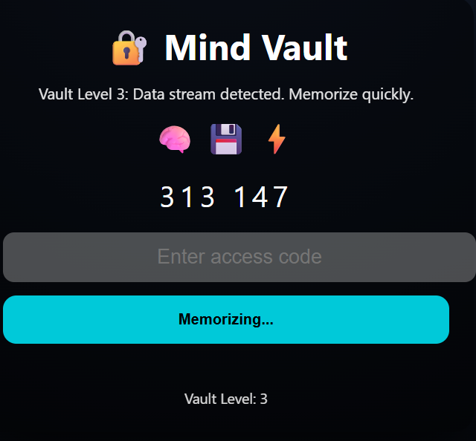
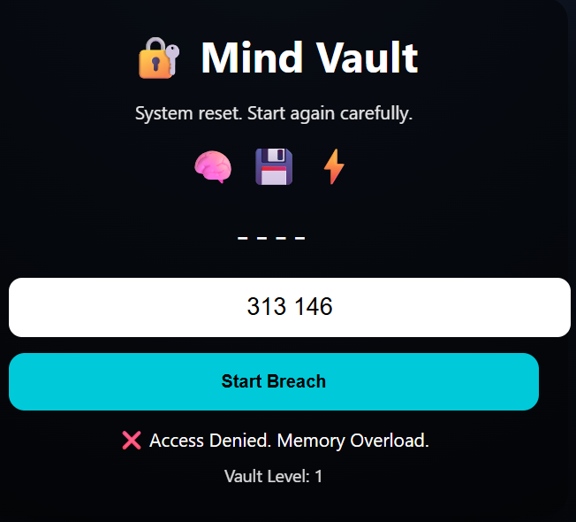

ABSTRACT
Mind Vault is an interactive, game-based web application designed to improve human memory performance using cognitive psychology principles such as chunking, recall, and recognition. Instead of traditional memorization methods, the system places users in a simulated “digital vault” environment where they must remember and recall information under time pressure. The game gradually increases difficulty levels, encouraging users to adopt effective memory strategies while maintaining engagement through storytelling and feedback mechanisms.
INTRODUCTION
Memory plays a crucial role in learning and decision-making. However, traditional learning methods often fail to actively engage users or strengthen long-term retention. To address this problem, the Mind Vault game integrates cognitive learning techniques into an interactive environment.
The game focuses on three core memory principles:
- Chunking – Breaking large amounts of information into smaller, manageable units
- Recall – Actively retrieving stored information without visual aid
- Recognition – Using visual icons and contextual cues to support memory
By combining these principles with game mechanics, Mind Vault makes memory training both effective and engaging.
PROBLEM STATEMENT
Conventional learning methods rely heavily on passive reading and repetition, which often results in low engagement and poor retention. There is a need for an interactive system that actively trains memory skills while keeping users motivated through meaningful challenges.
OBJECTIVE
The main objectives of this project are:
- To design a game-based system that improves memory skills
- To apply chunking, recall, and recognition in a practical way
- To encourage user engagement through levels, feedback, and story-based interaction
- To demonstrate cognitive psychology concepts using web technologies
KEY FEATURES
- Chunk-Based Information Display
Information is grouped into small chunks, reducing cognitive load and improving memorization.
- Active Recall Mechanism
Users must reproduce the information from memory after it is hidden, strengthening long-term retention.
- Recognition Support Using Icons
Visual icons provide contextual clues that aid recognition without revealing the answer.
- Progressive Difficulty Levels
Each level increases memory load and time pressure, encouraging skill improvement.
- Story-Driven Gameplay
A vault-breaching narrative motivates users and gives purpose to each task.
- Instant Feedback System
Immediate success or failure messages help users understand their performance.
- User-Friendly Interface
Simple, clean design ensures accessibility and ease of use.

TECHNOLOGIES USED
- HTML – Structure of the game
- CSS – Styling and user interface design
- JavaScript – Game logic and interactivity
APPLICATIONS
- Educational memory training tools
- Cognitive skill development for students
- Gamified learning platforms
- Human-computer interaction studies

CONCLUSION
Mind Vault successfully demonstrates how cognitive psychology principles can be applied through a game-based learning system. By combining chunking, recall, and recognition with interactive gameplay, the project provides an engaging and effective method for improving memory skills. This approach highlights the potential of gamification in modern education.

